Prior to travel I contacted Southwest Airlines and they told me that this Mobility Device is permitted as checked luggage. This is a Onewheel from Future Motion. This device specifications are permitted by both the U.S. Department of Transportation and Federal Aviation Administration. This device uses a Lithium Iron-Phosphate Battery it does NOT use a banned Lithium-Ion Battery. This battery has 130 watt-hours (printed on bottom of device) which is “more than 100 but less than 160 watt-hours” which is permitted. The battery is attached securely to the device and is protected against short circuit as it is enclosed in a battery container as is required. This is NOT a “Hoverboard” and uses completely different technology that is permitted for flying.

Please see further information below.
Thank you,
Name Number
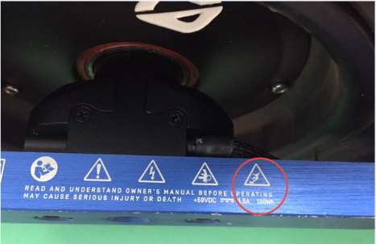
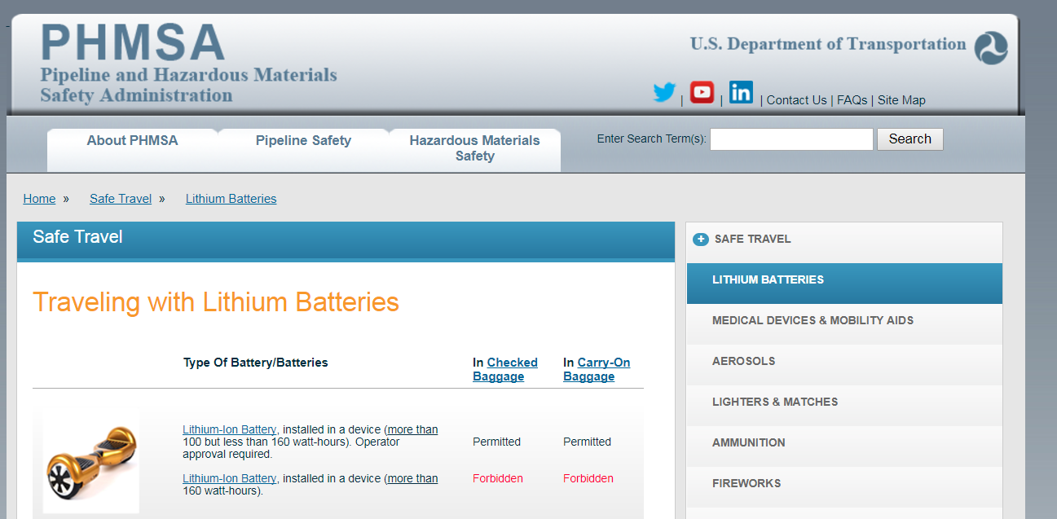
U.S. Department of Transportation https://phmsa.dot.gov/safetravel/batteries 130 watt-hours printed on bottom of device

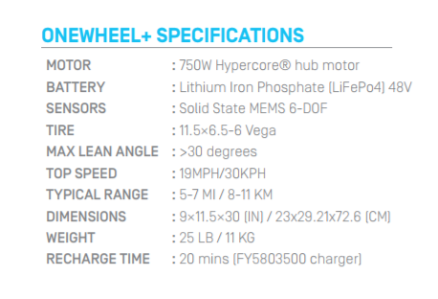
Lithium-Iron-Phosphate NOT Lithium-Ion Federal Aviation Administration
https://www.faa.gov/about/initiatives/hazmat_safety
